**JOBSHEET 2**

**Version Control System and Kanban Board**



**Name**

Sherly Lutfi Azkiah Sulistyawati

**NIM**

2341720241

**Class**

1I

**Department**

Information Technology

**Study Program**

D4 Informatics Engineering

Labs Activity

**Question! (Experiment 1)**

1. Explain the difference between **git commit** and **git push**?
2. In the above steps, we firstly create a repository in Github then clone it to the local computer to be modified. Is it possible to create the project folder and then push (upload) it to Github? Proove it!

**Answer!**

1. **git commit** saves repository changes on local but not remote repository, whereas **git push** updates the repository on GitHub with the changes you have made locally and sends it to remote repository.
2. Yes, it is possible to create the project folder and push it to Github. There is the way to do it:
3. Create new folder and java file in DASPRO-JOBSHEET2 Folder.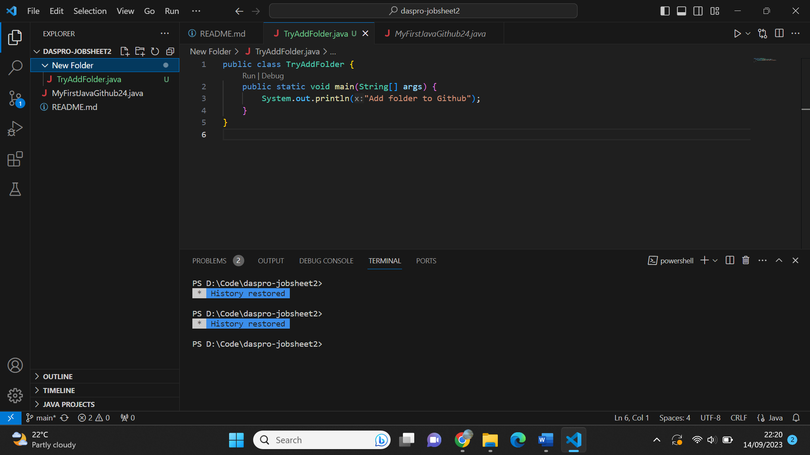
4. Select source control and add message, then click commit. 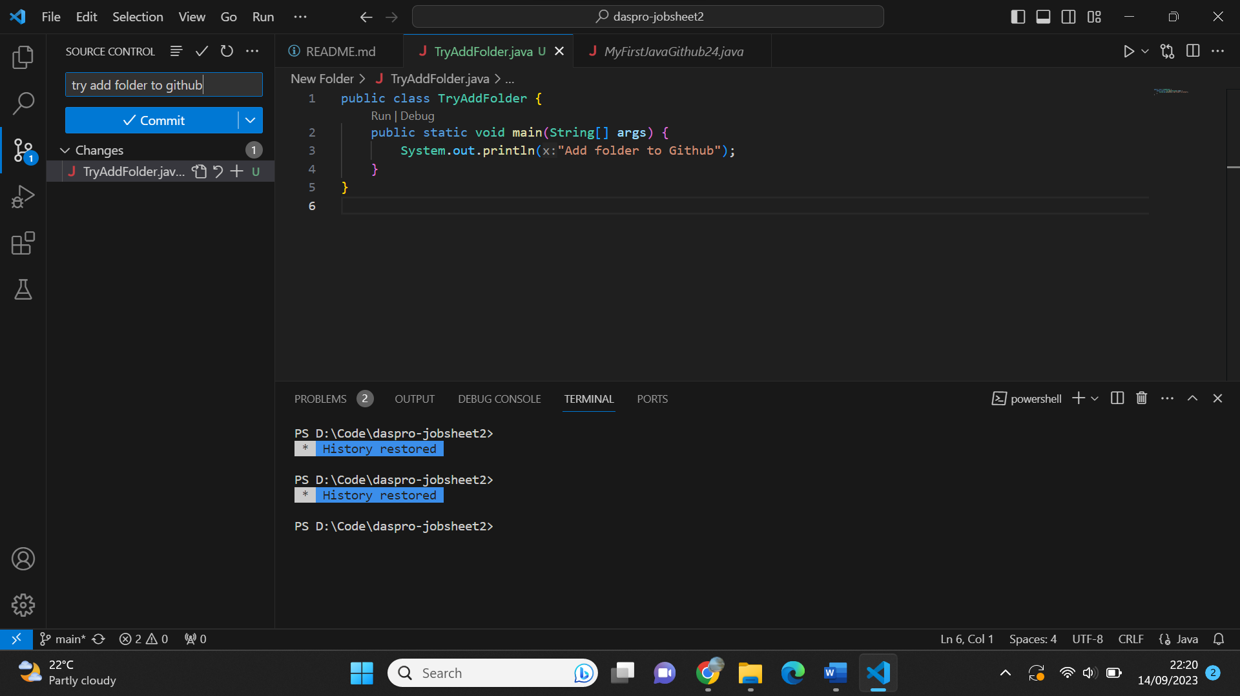
5. Click “Yes”

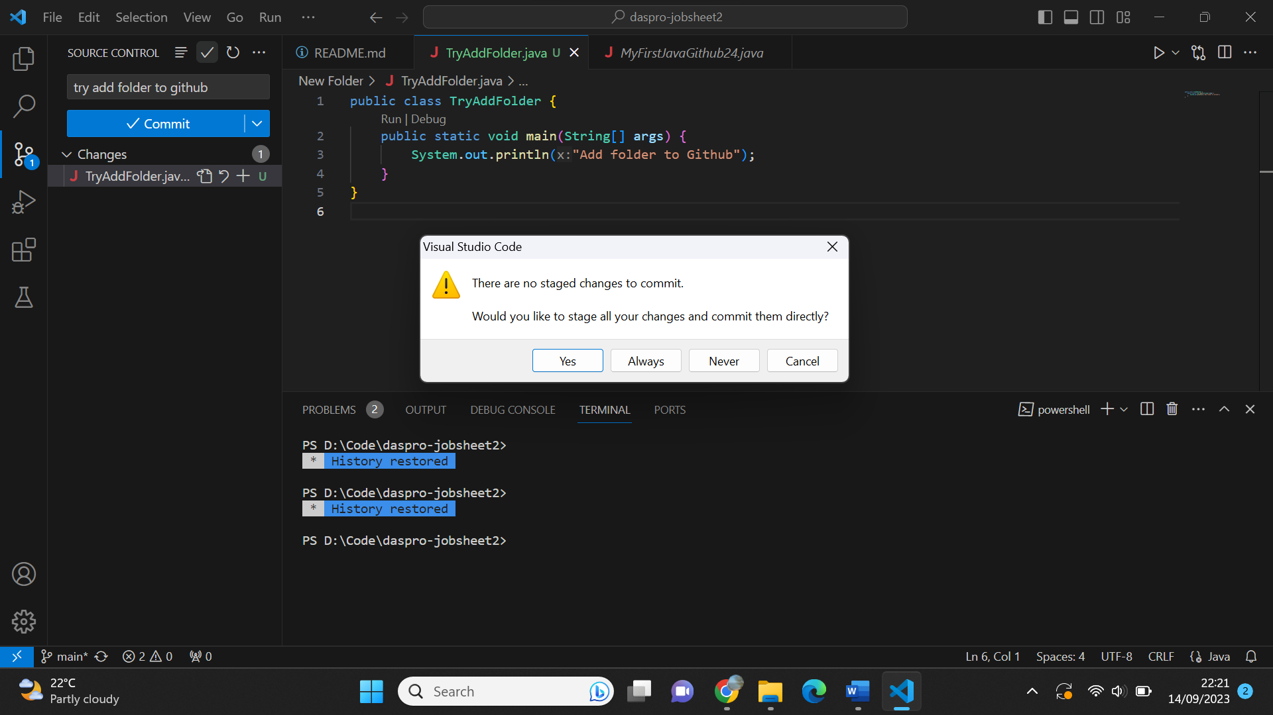

1. Click “Sync Changes” to get updates.

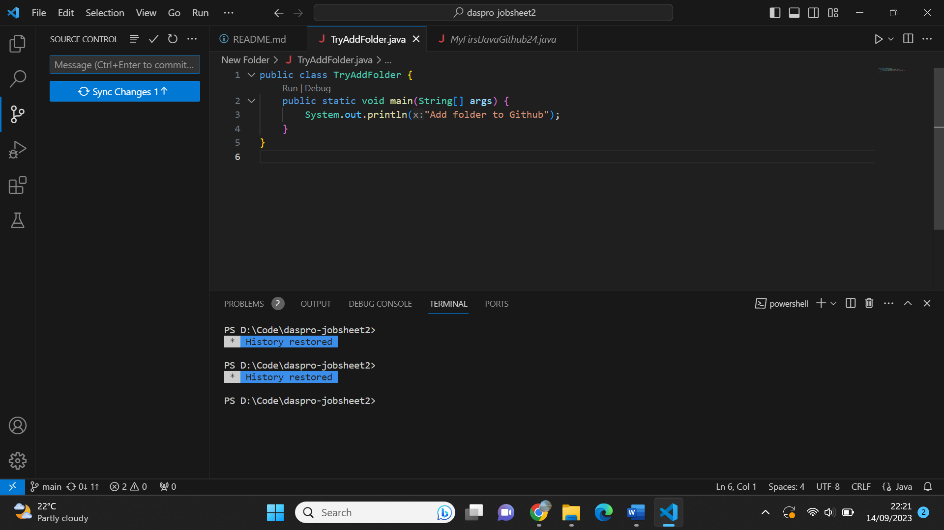

1. Check your Github for updates.

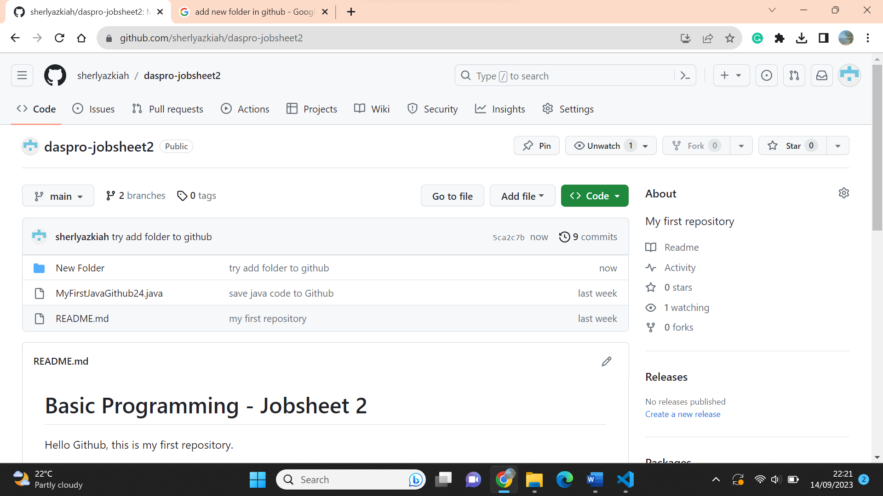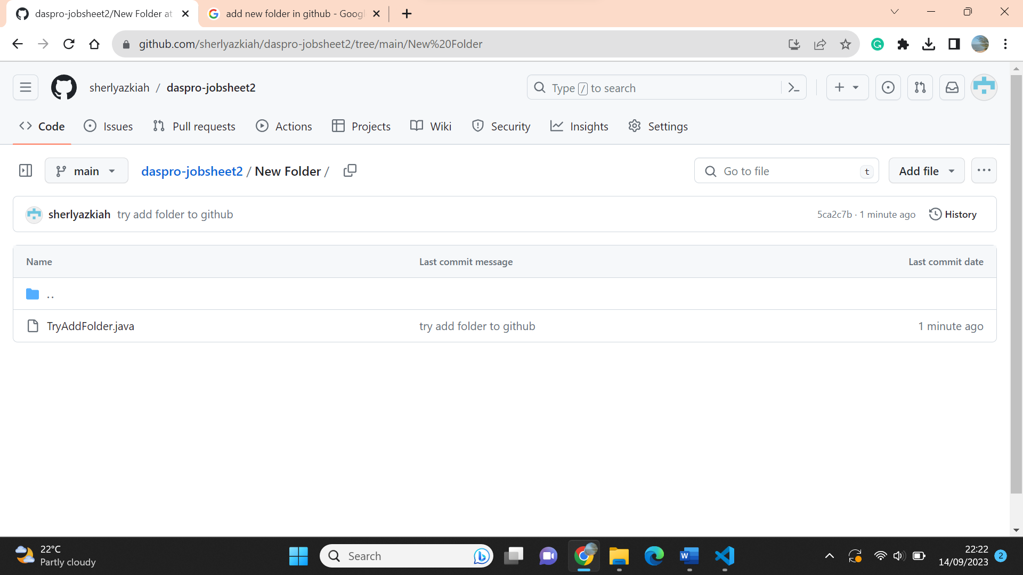

**Question! (Experiment 2)**

1. What is the use of **Pull requests**?
2. Why do we need to create **branch**?

**Answer!**

1. **Pull requests** are specific request to merge change from one branch into another, often for code review and integration before merging.
2. **branch** allow us to create separate context where we can try new things (develop features, fix bugs, or safely experiment) or even work on multiple ideas parallel without risking the codebase.

**Question! (Experiment 3)**

1. What steps do you take to invite team members to join your board?
2. Is it possible to make a board not from scratch (adding a list one by one), if so, how we can do that?

**Answer!**

1. Select Share from the board menu. Then, search for a user by name or enter an email address to invite them on the board. Click their name to add them to the board. By using this method, you may need to be an admin to invite someone to the board. Or you can invite others by sharing a special link with them, anyone with that link will be able to automatically join your board.
2. Yes, it is possible. You can use template from Trello by select a template that matches your project or workflow.

**Assignment**

1. Make groups/teams, and there are 3 students in each team!
2. Create a repository based on the topic chosen by your group, invite all team members to the repository. 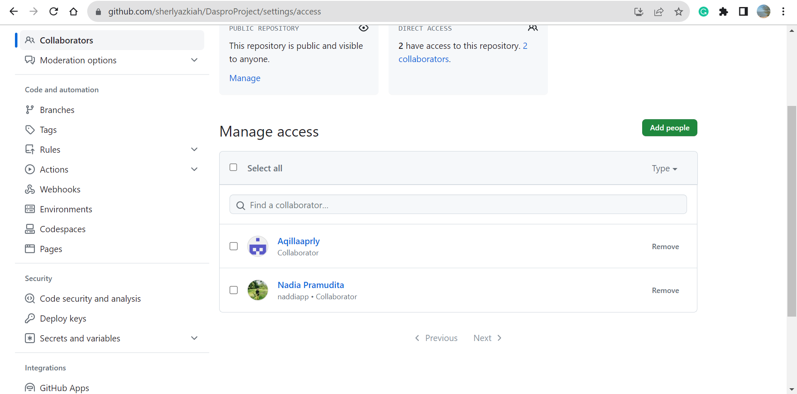
3. Create a Kanban Board with a board title complete with cards according to the project topic your group has chosen, invite all team members to the board.

